**Project Requirements and System Specification**

**Purpose**: During the pandemic, many industries faced supply shortages; chip manufacturing was one such industry. Raw materials were difficult to obtain, and as such, fabrication of key integrated chips was difficult, resulting in a rise in cost for product manufacturers. The purpose of our electronic speed controller, Hermes, is to create a product that doesn’t rely on chips from centralized sources and perform better than commercial products that rely on monolithic sources. Using more-readily available parts will allow for a more-robust product that doesn’t fail due to supply-chain shortages and black-swan events.

Figure 1: Project Development Lifecycle

**Requirements**: Hermes is an ESC that runs the sensorless FOC algorithm. The BLDC chosen to test is a Multistar Turnigy 3508-580. This is a quadcopter motor and is commonly used by hobbyists.

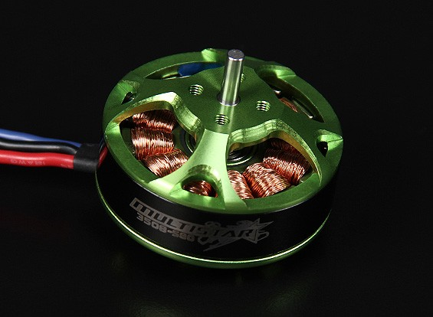

Several objectives of the project are:

* Simulate the sensorless FOC algorithm using Simulink, Simscape, and MATLAB by creating models and using pre-built blocks. After verifying the algorithm, design of the board will proceed.
* Design of a simple GUI/Terminal interface to communicate with the ESC.
* Building of a website to market the product.
* Schematic Capture, Layout, Assembly, and Troubleshooting of PCB.
* Compare torque and speed performance to alternative ESCs.

**Specifications:**

* Current – 30 to 40A
* Voltage – 8.4 - 25.2V
* SBEC: 3A/12V (Buzz word for linear regulator)
* Dimensions – TBD
* Weight – TBD

**Features:**

* ARM Cortex-M4 MCU
* Programmable
* On-board Temperature Sensor
* Multiple Communication methods – PWM, USB, CAN
* LED Fuse Indicator
* Stalled Motor Protection
* Safe power-on (throttle lockout)
* Current Limiting
* Smooth and linear throttle control
* Fast response to throttle input
* Brake
* Buzzer Alert

**Future Features:**

* Stepper-Motor feature
* Field Weakening control (increase max speed while decreasing torque)
  + [**https://www.mathworks.com/help/mcb/gs/field-weakening-control-mtpa-pmsm.html**](https://www.mathworks.com/help/mcb/gs/field-weakening-control-mtpa-pmsm.html)
* Regenerative braking
* LED control

**Issue #1: Detecting rotor position at start-up and low-speeds.**

**Problem**: At low speeds, FOC has a problem with detecting the rotor position because the back emf is low. Unlike PMSM, where the back-emf is sinusoidal, BLDCs have a trapezial back-emf, resulting in a low signal at slow speeds. Industry has two solutions to the startup problem:

• **Align-and-Go:** Force a voltage along one phase to force the rotor into a known state.

• **Initial Position Detect:** Used when we cannot move the propeller or wings. We can get the position of the rotor by locating the smallest motor winding inductance using voltage pulses and current saturation. See https://e2e.ti.com/blogs_/b/industrial_strength/posts/start-your-bldc-journey-with-motor-startup-part-iii-initial-position-detection-ipd for details.

For the low-speed problem, TI stores several previous angles in firmware to track its position. If we can predict its position, then using the Back-emf reading, we may be good. Another solution I thought of is to add an OP-Amp gain stage with high bandwidth to increase the differential signal of the shunt, that way even if the back-emf is small, we can amplify it suitably.

**Solution**: For simplicity, we will use **Align-and-Go** for the start-up; for low-speed, we can store the angles in memory.

**Notes 1: Sensing Rotor Position using Back-EMF**

Back-emf detection is the most common method to sense the rotor position. There are two types of back-emf sensing techniques:

* **Direct**: The back-emf of the floating phase is sensed and its zero crossing is compared with neutral point voltage. This suffers from high common mode voltage and high frequency noise due to the PWM drive, so it requires low-pass filters and voltage dividers. These methods are called.
  + Back-EMF Zero Crossing Detection (ZCD) or Terminal Voltage Sensing
  + PWM Strategies
* **Indirect**: Since filtering introduced commutation delay at high speeds and attenuation causes reduction of signal sensitivity at low speeds, the speed range is narrowed in the direct back-emf detection. To reduce switching noise, indirect methods work best.
  + Back-EMF Integration
  + Third harmonic Voltage Integration
  + Free-Wheeling Diode Conduction or Terminal Current Sensing

**Method 1: Terminal Voltage Sensing (Simplest)**

* Detect the instant at which the back-emf of the unexcited phase crosses zero. The zero crossing triggers a timer (RC Constant or something) so that the next inverter commutation (state switch) occurs at the end of this timing interval.
* “This sounds like a lot of fine tuning”